***Practical Implementation of MongoDB***

To demonstrate a variety of MongoDB operations, we'll go through several key concepts and commands. Here are the steps:

1. **Setting Up MongoDB:**
   * Install MongoDB.
   * Start the MongoDB server.
   * Use MongoDB Shell (mongosh) for interaction.

### 

### 2. **Basic CRUD Operations**

#### **a. Create (Insert Documents)**

**Code:**

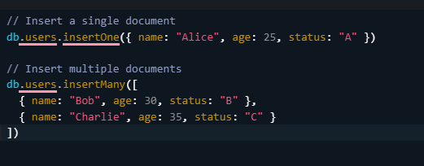

**Screenshot:**

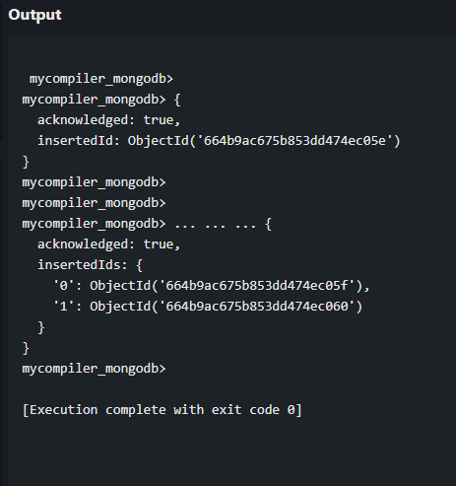

#### **b. Read (Query Documents)**

**Code:**

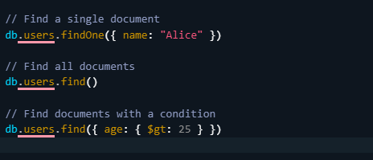

**Screenshot:**

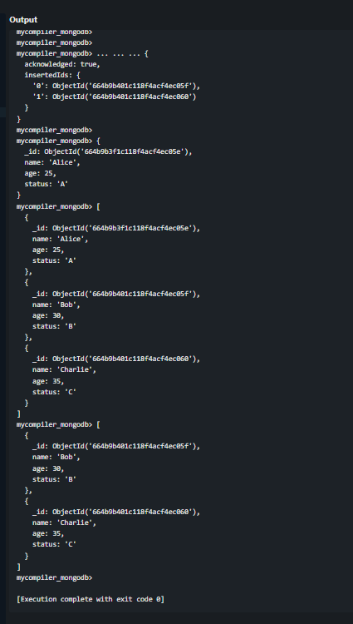

#### **c. Update (Modify Documents)**

**Code:**

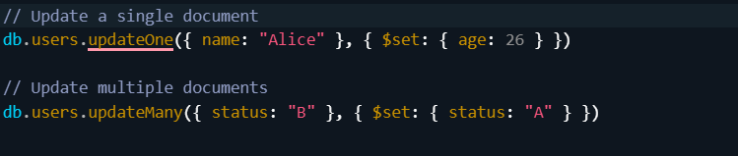

**Screenshot:**

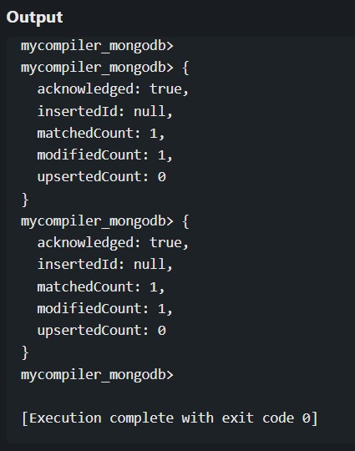

#### 

#### **d. Delete (Remove Documents)**

**Code:**

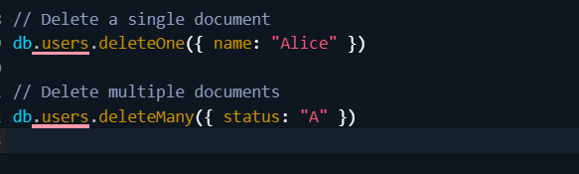

**Screenshot:**

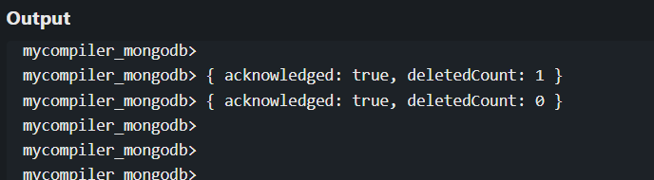

### **3. Advanced Operations**

#### **a. Indexing**

**Code:**

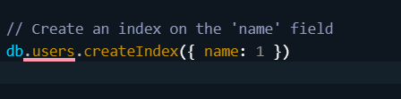

**Screenshot:**

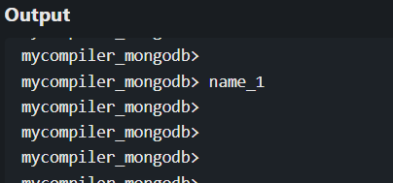

#### **b. Aggregation**

**Code:**

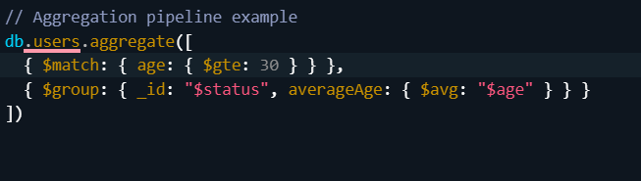

**Screenshot:**

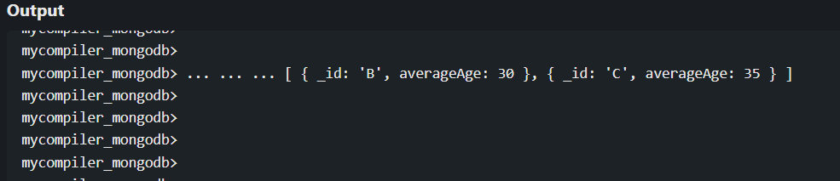

#### **c. Geospatial Queries**

**Code:**

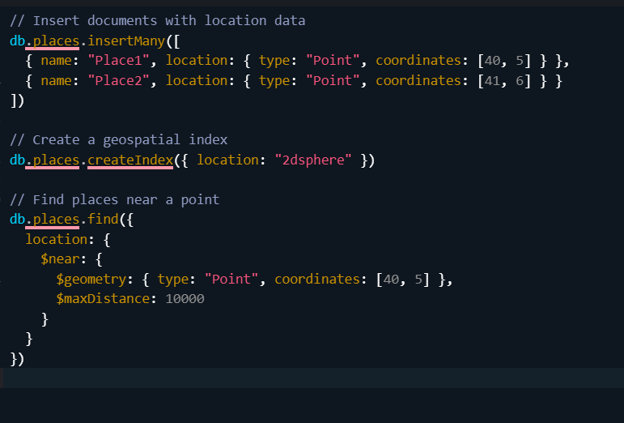

**Screenshot:**

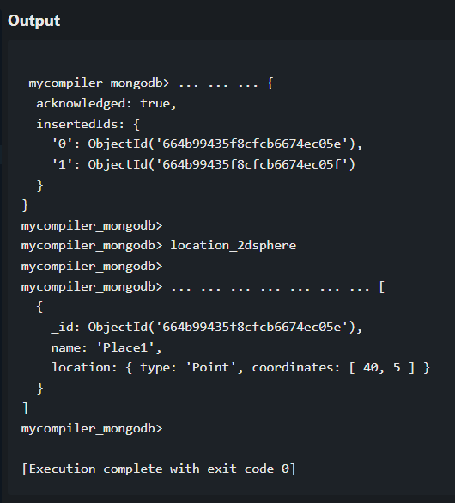

#### **d. Text Search**

**Code:**

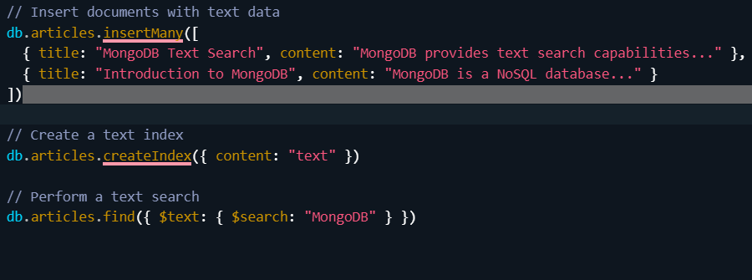

**Screenshot:**

